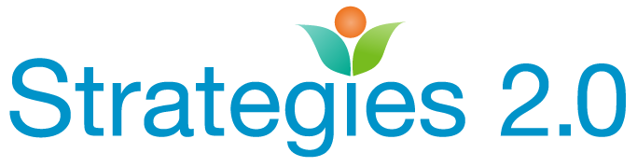

Highlights of the March 7, 2018 Sierra Nevada Learning Community

Link to the recording: March 7, 2018 Sierra Nevada Learning Community

Highlights of Nada Yorke’s presentation on ACES and Intimate Partner Violence (IPV):

Nada Yorke, LCSW and trainer from Yorke Consulting, asked participants to think about the terminology they use to describe their clients. How we refer to our clients can frequently impact the way we approach our work. Next, we looked at the impact of ACES on both the perpetrators of IPV, and those that have survived IPV.

Attendees were asked to estimate the impact of ACES on the people they serve. Overall, attendees estimated that 70-90% of their client population experienced at least 4 or more ACES. Clearly, as we work with IPV perpetrators and survivors, education on ACES and its impact would be beneficial. Attendees learned about IPV, power and control and stages of change. Access to resources to assist both perpetrators and survivors was discussed. Participants listed the following barriers to accessing services and holding batterers accountable:

Issues in accessing services:
Transportation
Stable housing
Stigma; shame
Language
Unaware of resources/lack of resources
Mistrust of system
Victim is still living with perpetrator
Judgmental staff /unwelcoming staff/ lack of coordination with other providers

Barriers to Providing Culturally Competent Resources:
Language
Family dynamics
Historical experience
Intergenerational trauma
Lack of funding
Lack of diversity in staff
Isolation/lack of resources
Biases
Immigration status
Cultural understanding/humility
Fear children will be removed
Barriers to Holding Offenders Accountable:
Fear of no action by system
Social norms that make IPV acceptable
Culture of victim blaming
Justice system response—who is the primary aggressor when there is “mutual combat”
Concerns about escalating violence by intervening
Charm of perpetrator
Lack of time for Law Enforcement
Funding for services
Not enough women in power
Perpetrator protected by the system
Lack of resources in jails
Victims concerned about loss
High profile offender
Higher income folks have resources to hide abuse
No follow-up for perpetrators and survivors

Need partners to help address these issues. No one system can do it alone. Ideas to include:
Peer support system
Mental health
Survivors
Substance abuse
Law enforcement
Corporations
Victim/Witness programs
Children’s Services including CASA
Court; DA; Probation and Parole
Beauty/Wellness-hair stylist, nail salons, wellness programs
Schools
Medical/ER
First responders (medical, fire, police)
Public health
Churches
Bartenders/hotel workers
Community Leaders and elected officials
Childcare providers
Girls and Boys Clubs
Coaches

Next steps identified by participants:

Reporting harm when they see it, listening and collaborating across systems.
Find out about batterer’s programs—where are they? Implement in jails
Learn about signs of IPV, implement healthy relationship class, provide more public information.
Outreach to the medical community.
Make sure to focus on IPV, not only addiction.
Training for staff that encounter potential victims and perpetrators.
Get decision makers to the table.
Reach out to hotel association and try to partner to provide housing for families waiting for space in a shelter.

If you have not already, don’t forget to partner with your local library system to purchase the movie Resilience at the special library rate of $95. The movie is then accessible to anyone for free through the library circulation (El Dorado and Mono County have done this successfully).

