Adverse Childhood Experiences (ACEs)

Recommended reading for session:
- Garner AS et al. Translating Developmental Science to Address Childhood Adversity. Acad Pediatr. 2015; 15(5): 493-502

Goal: To enable students to review the current literature on ACEs and to engage in an interactive, case-based small group discussion on ACEs.
Objectives: By the end of the session, students will be able to:

1. Outline adult physical and mental health consequences of adverse childhood experiences (ACEs).
2. Discuss the use of the ACE survey in the medical home and how this may assist physicians to better engage and care for their patients.
3. Describe the impact of resilience on mitigating the negative health consequences of ACEs, and outline interventions based in trauma-informed care, which may include office and community-based support as well as appropriate medical and mental health referrals.

1. EXERCISE – CASE DISCUSSION (120 minutes)

Student Page 1
Case Overview
Simone Baker is a 20 year-old mother of two. She has a three year-old son, Zaire, from a high school relationship, and now presents to the pediatric clinic with her 4 month old daughter, Amber. Amber was born at term at University hospital by normal spontaneous vaginal delivery weighing 7 pounds and 1 ounce. Simone had good prenatal care and had no prenatal complications. Amber did well in the neonatal period and was discharged home with her mother at 2 days of age. Simone tried to breast feed Amber, but became frustrated—she felt her milk supply was insufficient—and by two weeks of age, Amber was taking only formula. The baby has been growing well and is here for her second set of vaccines. Although the infant is doing well, mom seems very tired and has a flat affect. She says it is harder this time because she has no support at home, CJ, her boyfriend and father of Amber is working most of the time, and she has no outside support. When Zaire was born Simone was living at home with her mother and sister and they helped quite a bit and gave her a break once in a while. Simone is now living in a single room apartment with Zaire, Amber, and CJ. She had to quit working about 4 months into her pregnancy with Amber because she couldn’t stand on her feet all day long, and she doesn’t plan to go back to work until Amber is at least 6 months of age.
Prompting questions:
- What concerns do you have at this time?
- What questions would you ask to better understand Simone’s situation and her current state of mental health?

Student Pages 2 and 3
You are concerned that Simone is feeling overwhelmed with her responsibilities and may be experiencing some post-partum depression. You want to find out more about her social history, her life growing up and her past health and mental health history. You explain to Simone that it may be helpful to you to go over some questions about her childhood experiences by doing an ACE score.
Complete and score the ACE survey based on the following information:
Simone grew up in a household headed by a single mother. She was the youngest of three children – she had a maternal half-sister, Marie, who was 10 years older and a maternal half-brother, Tyrone, who was 8 years older than her. Her own father was an infrequent visitor in her life, and he would come by periodically to see her and take her out to eat or spend a day, but he provided little financially for her. He was kind enough to her, but he was in and out of jail himself and had a serious substance use problem. Her mother worked two jobs to keep a roof over their head and food on the table. There were times when her mother was laid off when they did not have enough to eat, and the children depended on the school breakfast and lunch programs to get their food during the school year. When they were out of school in the summers, there were many days when they only had one or two meals.
Her mother was a strict disciplinarian and often used a belt or strap to exert her kind of discipline. Her mom was also verbally abusive, and Simone indicated that her mother would often swear at her and criticize her and her siblings for no reason. There were many times when Simone had bruises on her legs and buttocks from being beaten with the strap. Simone’s mother also suffered from bouts of severe depression that went on for several months at a time, during which she was unable to work. On two occasions, Simone and her siblings were placed in foster care because of their mother’s depression when she was hospitalized. In the past 5 years her mother has been treated with antidepressants and has not had any severe episodes of depression. Despite the ups and down, Simone says that she always felt that she was loved, especially by her siblings, who were protective of her and “had her back”.
When Simone was 5 years old, her mother’s boyfriend Ben came to live with them. Ben was tolerant of the children, but had a rocky relationship with her mother. He was a drinker, and at least once a week became intoxicated and would often hit, slap or beat her mother. At times her mother locked herself in her room, and Ben would eventually fall asleep on the couch. One time Ben even held a knife to her mother’s throat, but she managed to scramble away. He lived with them for about three years before her mother finally tossed him out.
Outside of her home, Simone liked her classmates and school for the most part. She was a decent student and her sister helped her with her homework. She did not feel discriminated against in her community and denies being bullied as a child. Her neighborhood, however, was not all that safe, and she and her siblings never went outside at night because of the drug activities near her home. Several of her friends in high school who lived on her block were robbed at gunpoint when walking home from evening jobs. Simone denies ever being sexually assaulted or being coerced to have sex as a child. Simone was 16 years old when she became pregnant with her boyfriend, Lemar, who was 17 years old. Simone dropped out of school when Zaire was born, but got her GED last year before she became pregnant with Amber.
Simone’s mother developed severe diabetes in her 30s and as a result had an amputation of her left lower leg. Her mother is now in her 50s and living in housing for disabled people; she is a wheelchair user. When her mother went into this placement, Simone had to move out on her own. She moved into her current apartment with CJ, and brought her son Zaire along. When asked if she has ever had any episodes of depression herself, Simone says that in 9th grade she saw a counselor at her high school because she was feeling really down and had been cutting herself. She has never seen a psychiatrist nor taken any medication for depression or anxiety. Since Amber has been born, however, she has been feeling really, really sad and is having trouble getting up in the morning to provide care for Zaire and Amber. She says all she wants to do is sleep and has lost 15 pounds because she has almost no appetite.

Student Page 4
ACE Survey
While you were growing up, during your first 18 years of life: Circle Yes/No
- Did a parent, step-parent or other adult in the household often or very often…  Swear at you, insult you, put you down, or humiliate you?  or  Act in a way that made you afraid that you might be physically hurt? | YES or NO
- Did a parent, step-parent or other adult in the household often or very often…  Push, grab, slap, or throw something at you?  or  Ever hit you so hard that you had marks or were injured? | YES or NO
- Did an adult or person at least 5 years older than you ever…  Touch or fondle you or have you touch their body in a sexual way?  or  Attempt or actually have oral, anal, or vaginal intercourse with you? | YES or NO
- Did you often or very often feel that …  No one in your family loved you or thought you were important or special?  or  Your family didn’t look out for each other, feel close to each other, or support each other? | YES or NO
- Did you often or very often feel that …  You didn’t have enough to eat, had to wear dirty clothes, and had no one to protect you?  or  Your parents were too drunk or high to take care of you or take you to the doctor if you needed it? | YES or NO
- Were your parents ever separated or divorced? | YES or NO
- Was your parent, step-parent or another adult who was helping to raise you:  Often or very often pushed, grabbed, slapped, or had something thrown at her/him?  or  Sometimes, often, or very often kicked, bitten, hit with a fist, or hit with something hard?  or  Ever repeatedly hit over at least a few minutes or threatened with a gun or knife? | YES or NO
- Did you live with anyone who was a problem drinker or alcoholic, or who used street drugs? | YES or NO
- Was a household member depressed or mentally ill, or did a household member attempt suicide? | YES or NO
- Did a household member go to prison? | YES or NO
- Did you see or hear someone being beaten up, stabbed, or shot in real life multiple times? | YES or NO
- Did you often, very often or sometimes feel that you were treated badly or unfairly because of your race or ethnicity? | YES or NO
- Did you feel unsafe in your neighborhood some, most or all of the time? | YES or NO
- Were you bullied by a peer or classmate all of the time or most of the time? | YES or NO
- Were you ever in foster care? | YES or NO
Total ACE score:
Student Page 5
Prompting questions:
- Based on her story, what is her ACE score?
- If any score at or above four is considered high risk, what does Simone’s score indicate to you?
- What future health risks are more of a concern for Simone compared to someone with a low ACE score?
- What advice can you give Simone to help decrease her chances of developing long term health complications?
- What other interventions or referrals would you suggest at this time?
Because of her signs of depression, you refer her for mental health services; she is connected with a psychologist for cognitive behavioral therapy and a psychiatrist to treat her depression.
Simone returns to your office three months later with Amber. She appears much more animated and responsive. She is smiling and tells you she is feeling much better. She says that she is taking an antidepressant and has much more energy. She has a good appetite and feels better being home with her children.
Simone tells you that her therapist had her complete something called a resilience survey and that it has helped her to see some of the positives in her life growing up and now. She has been back at work for the past two weeks and has been accepted into a management training program that will offer her potential for advancement at the retail store where she works, and also offers reimbursement for college classes. She plans to get her associate’s degree over the next four years by picking up a few credits at a time at the County College. Zaire goes to preschool and both children are also in daycare when she is working. Simone shares her resilience surveys with you.
As you look over her responses, she volunteers that her sister was a huge support to her during her “kinda rough” childhood. She says she is finally enjoying being a mom and is really excited about her employee training program and going back to school. She says she sometimes needs a break from parenting; her work and having the children in pre-school and daycare give her a chance to be an adult, so she can be more attentive to their needs when she is home with them.

Student Page 6 and 7
Childhood Resilience Survey
Take time to reflect on the following based on your experiences growing up.
Item | YES | NO | Notes
- Someone in my family often stood by me in hard times |  |  | Sister
- I had someone in my family to talk with about difficult feelings |  |  | Sister
- I often felt supported by friends
- I often felt a sense of belonging in high school
- I often enjoyed community traditions
- I often had at least 2 adults, other than my parents, who took an interest in me

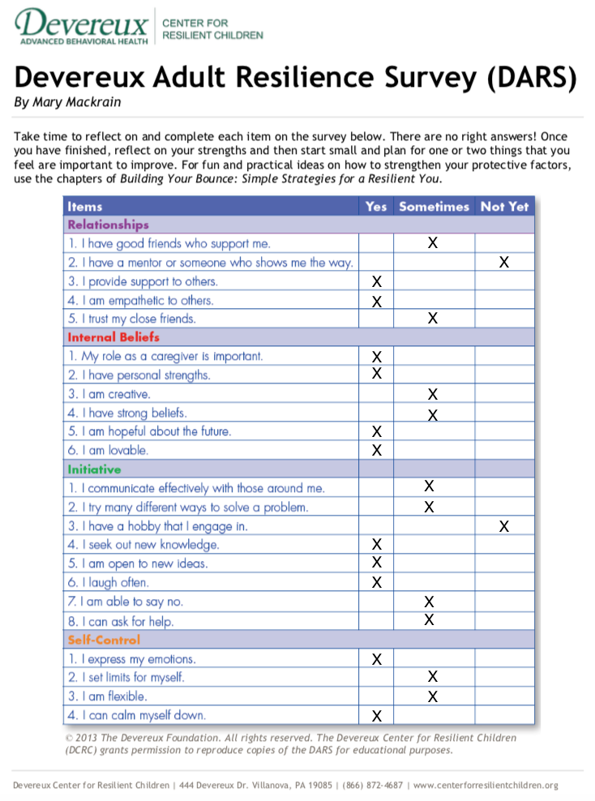
Student Page 8

Prompting questions based on Simone’s completed resilience surveys:
- How do you define resilience?
- What sources of resilience did Simone identify, during her youth and currently?
- How do you feel these surveys can be used in helping someone with a high ACE score?
- Do you think that the ACE and/or resilience surveys could be useful in a primary care setting? If so, why and how? If not, why not and what would be barriers to using these tools?

References:
1. Felitti VJ, Anda RF, Nordenberg D, et al. Relationship of childhood abuse and household dysfunction to many of the leading causes of death in adults: The Adverse Childhood Experiences. Am J Prev Med. 1998;14(4):245-258.
2. Earls MF. Trauma-Informed Primary Care : Prevention, Recognition, and Promoting Resilience. N C Med J. 2018;79(2):108-112.
3. Jones J, Bethell C, Linkenbach J, Sege R. Health effects of ACEs mitigated by positive childhood experiences. (manuscript Prep. 2017.
4. Mackrain M, Bruce N. Devereaux Adult Resilience Survey in: Building Your Bounce: Simple Strategies for a Resilient You. 2nd ed. Lewisville, NC: Kaplan; 2007.

