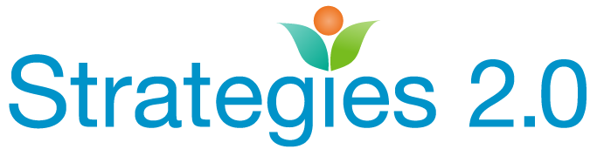

Strategies 2.0 is a catalyst for the professional skills, organizational structure, and community relationships necessary to mitigate the risk factors for child abuse and neglect, and to promote child, family, and community well-being.

Growing Knowledge, and Networks for Professionals Working with Families.

RESOURCES FOR AFFORDABLE HOUSING

The Corporation for Supportive Housing (CSH) has a wealth of resources on developing affordable, accessible and supportive housing in your community.

The CSH One Roof project has child welfare involved families as its focus. Read the 8-Steps-Roadmap to learn about the 8 steps to creating housing solutions for high-risk families.

Notes from the Field: Supportive Housing as a Platform for Family Stabilization: Lessons from a National Family Supportive Housing Demonstration

An Introduction to Supportive Housing for Vulnerable Families

Early Childhood Self-Assessment Tool for Family Supportive Housing This 22-page document provides concrete assessment tools and resources for agencies and families.

Crosswalk Early Childhood Home Visiting and Supportive Housing for Families

CSH is one of three providers contracted by the California Department of Housing and Community Development (HCD), Housing Policy Division, to provide Technical Assistance to Improve the Delivery of Homelessness Programs. CSH’s focus is on Housing and Stability which establishes or improves the rates of exits from homelessness into permanent housing for providers of supportive housing. Eligible recipients of this TA include California Counties and Continuums of Cares (CoC’s) that administer or receive a direct allocation from HCD of Emergency Solutions Grant and/or No Place Like Home. Counties and CoC’s can request TA on the HCD website at
https://www.hcd.ca.gov/grants-funding/already-have-funding/technical-assistance.shtml

